

**Library Management System Documentation**

**For: Maids.cc**

**Content List**

* **Data Base relations**
* **Authentication Controller**
* **Book Controller**
* **Patron Controller**
* **Borrowing Records Controller**
* **Security**
* **Examples For End Points**
* **Aspect Oriented Programming**
* **Unit Testing**
* **Transactional**
* **Swagger Documentation**
* **Caching**
* **Error Handling & Validations**

**By : Omar Mohamed Elaraby**

* **Data Base Relations:**

-Database my sql has been used for the project

-It is called library and it has 4 tables:

* + - * Book
      * Patron
      * Borrow Book Record
      * User

-Book has 5 columns:

* Id (**Primary Key**)
* Author (**Not null**)
* Title (**Not null**)
* Publication Year (**Not null**)
* ISBN (**Not null & Unique**)

-Patron has 4 columns:

* Id (**Primary Key**)
* Name (**Not null**)
* Mobile (**Not null**)
* Email (**Not null & Unique**)

- Borrow Book Record has 5 columns:

* Id (**Primary Key**)
* Book_Id (**Not null**)
* Patron_Id (**Not null**)
* Borrow Date (**Not null**)
* Return Date
* Book_Id , Patron_Id , Borrow Date , Return Date (**Unique**)

-User has 5 columns:

* Id (**Primary Key**)
* First name (**Not null**)
* Last name (**Not null**)
* Email (**Not null , Unique**)
* Password (**Not null**)

- Borrow Book Record has many to one relationship with Books and

many to one relationship with Patrons

-User table is created for authentication and authorization so it has no relationships with other table.

* **Authentication Controller:**

|  |  |  |  |  |
| --- | --- | --- | --- | --- |
| **End Point Name** | **Request Type** | **Path** | **Request Model** | **Response Model** |
| Add New User | Post | /api/auth/register | RegisterReqModel | AuthenticationResModel |
| Authenticate User | Post | /api/auth/authenticate | AuthenticationReqModel | AuthenticationResModel |

* **Book Controller:**

|  |  |  |  |  |
| --- | --- | --- | --- | --- |
| **End Point Name** | **Request Type** | **Path** | **Request Model** | **Response Model** |
| Get All Books | Get | /api/books?  PageNo=&PageSize= | ---------------- | BookResModel |
| Create New Book | Post | /api/books | BookReqModel | Integer |
| Get Book By Id | Get | /api/books/{id} | ----------------- | BookResModel |
| Update Book | Put | /api/books/{id} | BookReqModel | BookResModel |
| Delete Book | Delete | /api/books/{id} | ----------------- | ------------------- |

* **Patron Controller:**

|  |  |  |  |  |
| --- | --- | --- | --- | --- |
| **End Point Name** | **Request Type** | **Path** | **Request Model** | **Response Model** |
| Get All Patrons | Get | /api/Patrons?  PageNo=&PageSize= | ---------------- | PatronsResModel |
| Create New Patron | Post | /api/ Patrons | PatronsReqModel | Integer |
| Get Patron By Id | Get | /api/ Patrons /{id} | ----------------- | PatronsResModel |
| Update Patron | Put | /api/ Patrons /{id} | PatronsReqModel | PatronsResModel |
| Delete Patron | Delete | /api/ Patrons /{id} | ----------------- | ------------------- |

* **Borrowing Records Controller:**

|  |  |  |  |  |
| --- | --- | --- | --- | --- |
| **End Point Name** | **Request Type** | **Path** | **Request Model** | **Response Model** |
| Create New Borrowing Book Record | Post | /api/borrow/{bookId}  /patron/{patronId} | BorrowReqModel | Integer |
| Create New Book  Return Record | Put | /api/borrow/{bookId}  /patron/{patronId} | Return ReqModel | Void |

* **Security:**

-Creating authentication and authorization using **JWT bearer token**.

-The dependency “**io.jsonwebtoken**” used for implementing security for the project

-it is divided in to 2 steps:

* + - * Register user (**Sign up**)
      * Authenticate user (**Log in**)

-The authorization is only for 1 user so, can access for all methods.

* **Examples For End Points:**

1. **Register user**

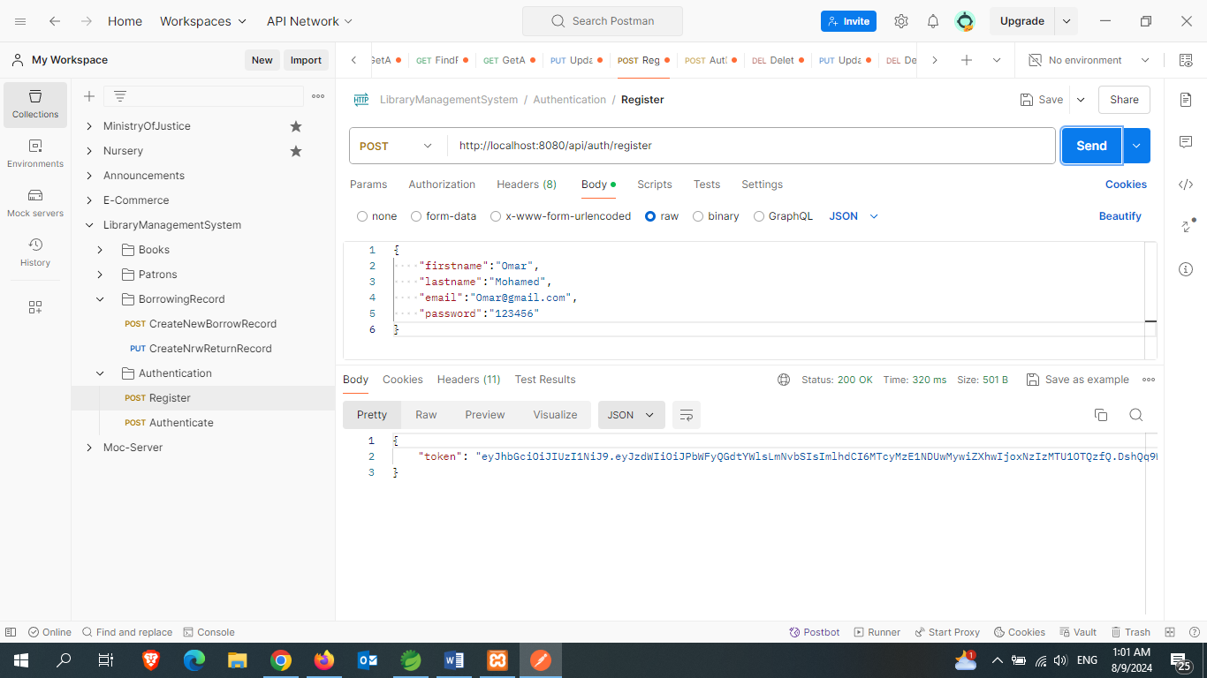

**-This token is not used for authentication but it represents that the user registered successfully**

1. **Authenticate user**

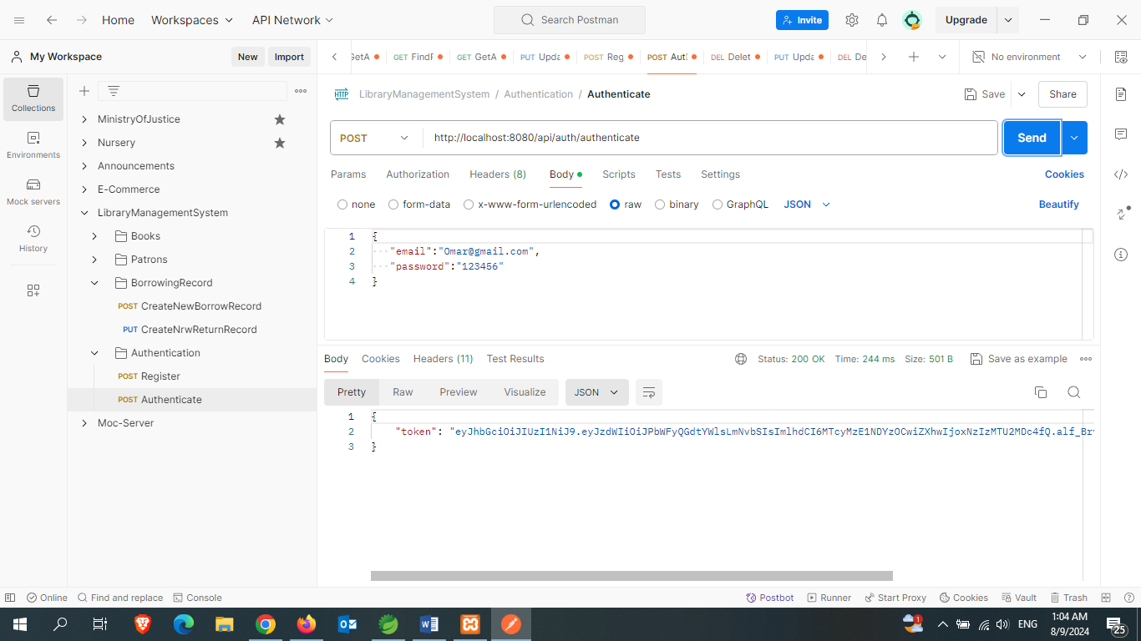

**-This token is used for user authentication. It will be put in authorization tab in postman as bearer token.**

1. **Add Book**

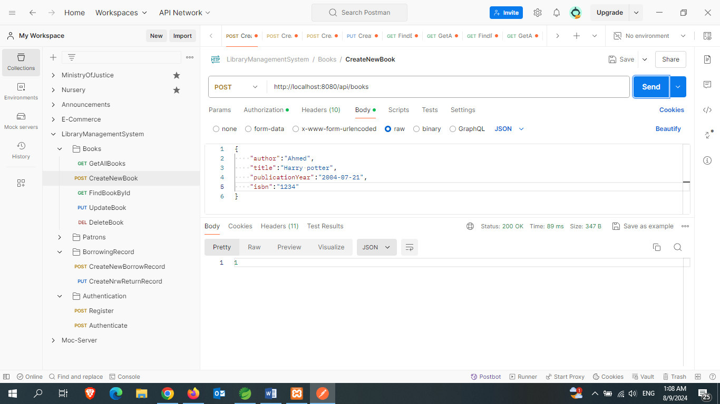

1. **Get All Books**

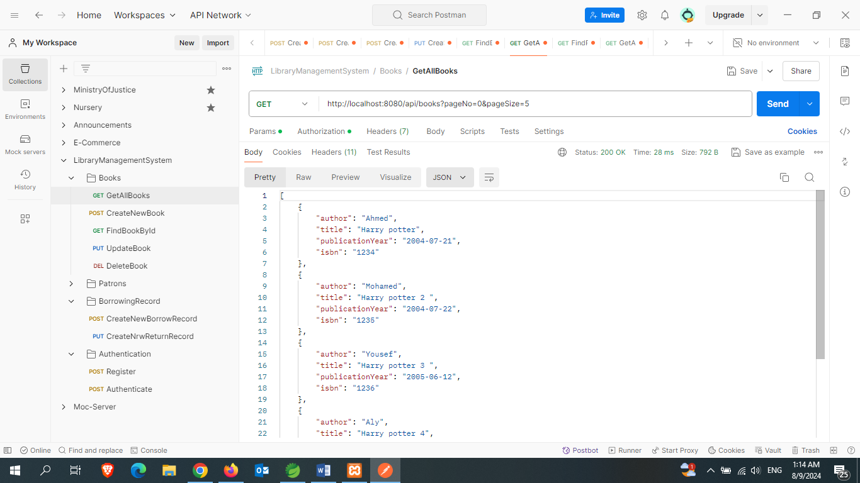

**-Using of pagination and page size to control number of data**

1. **Get Book By Id**

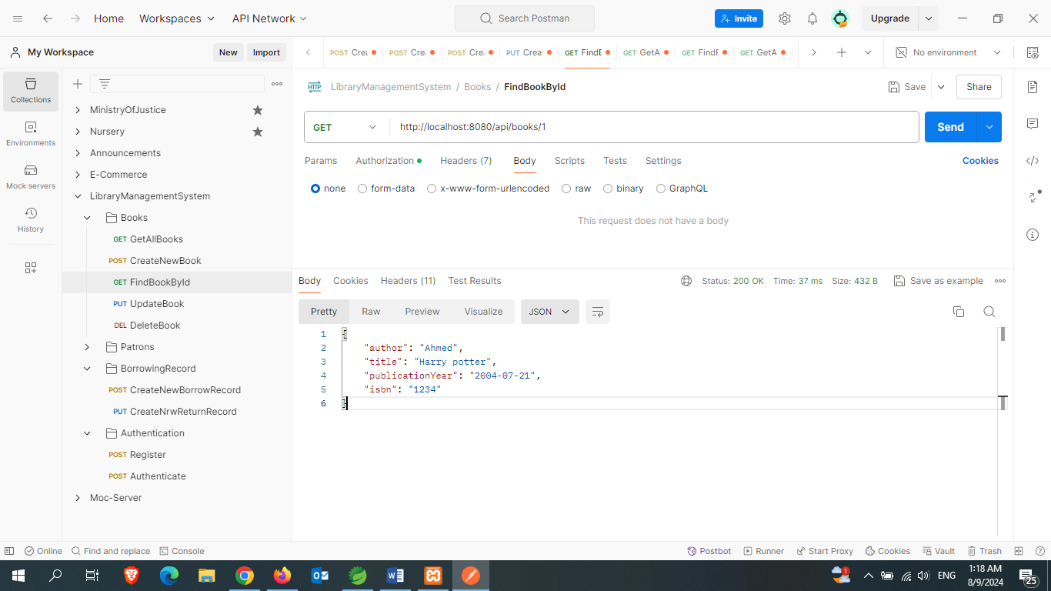

1. **Update Book**

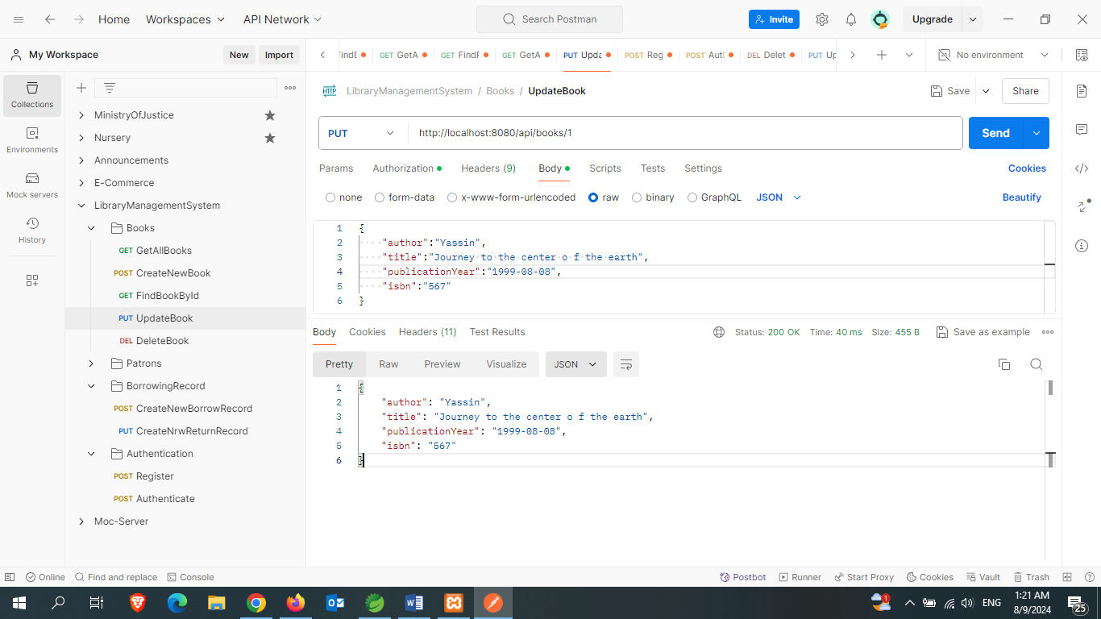

1. **Delete Book**

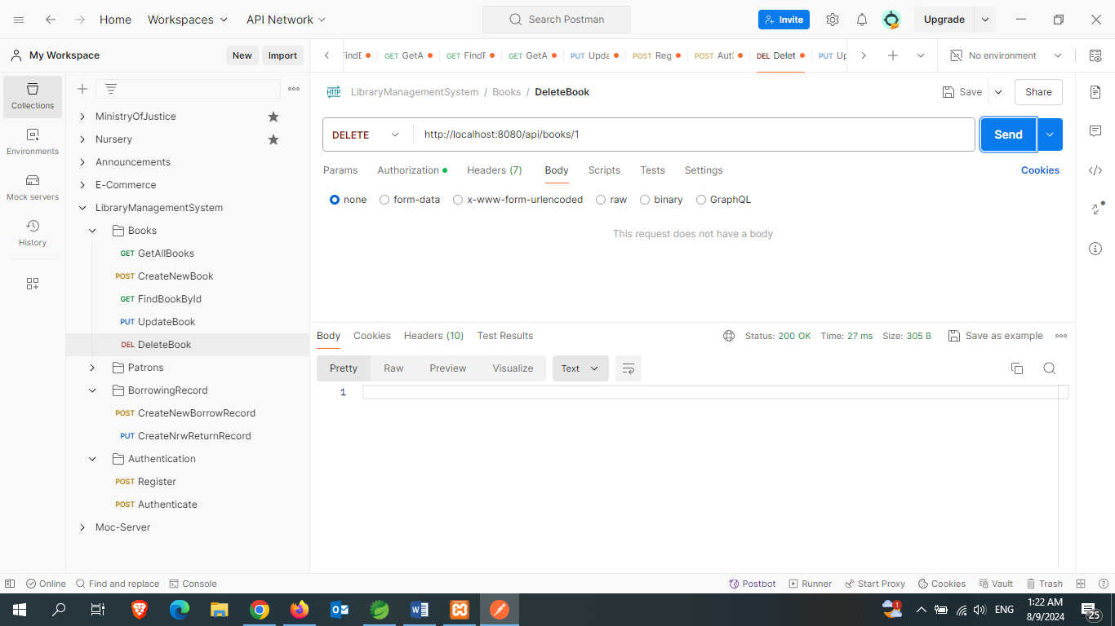

1. **Add Patron**

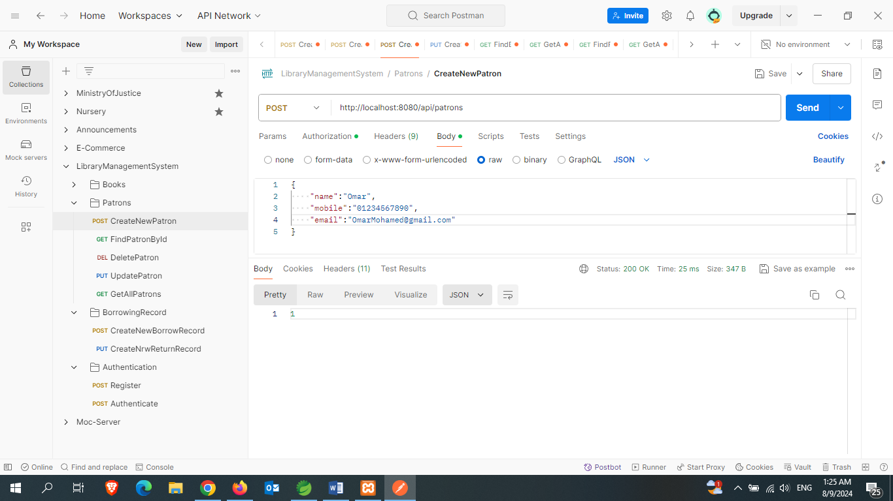

1. **Get All Patrons**

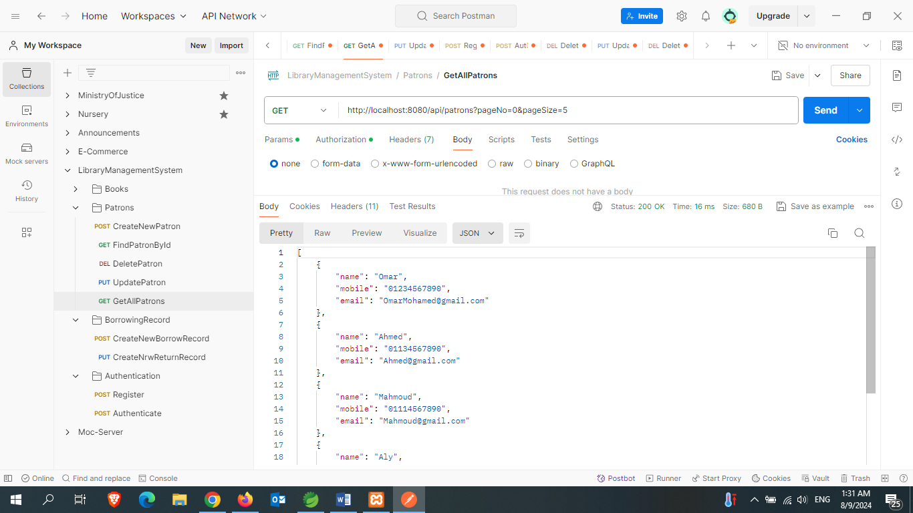

**-Using of pagination and page size to control number of data**

1. **Get Patron By Id**

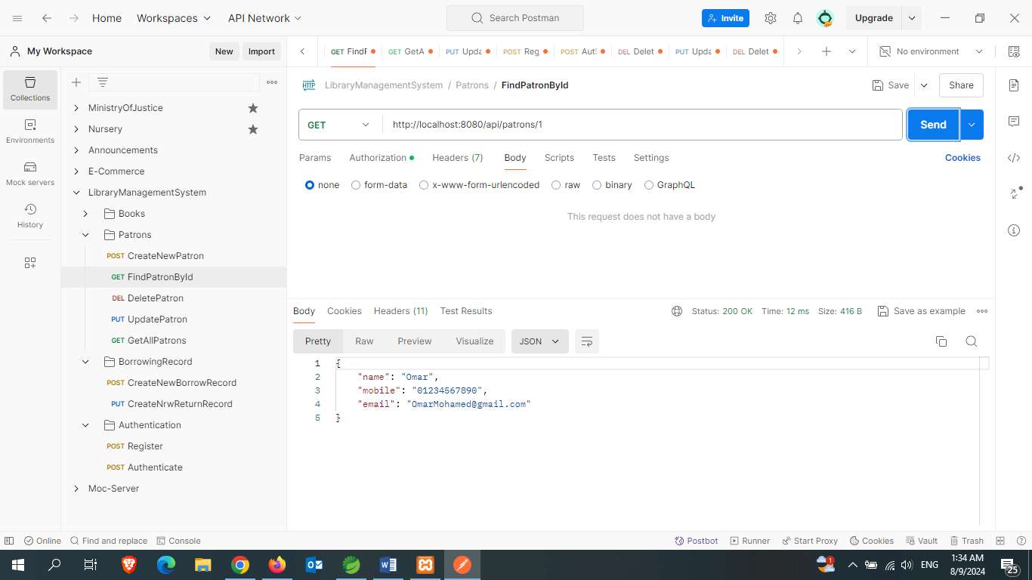

1. **Update Patron**

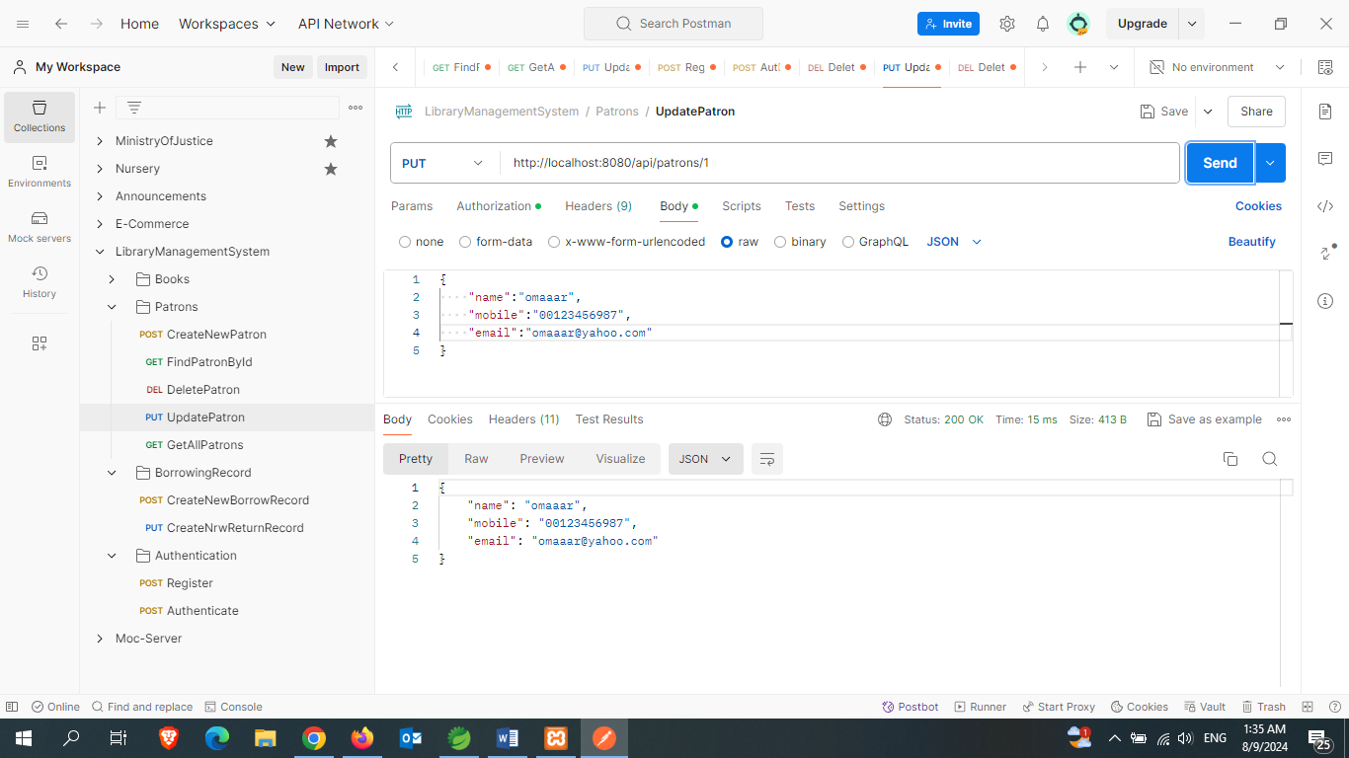

1. **Delete Patron**

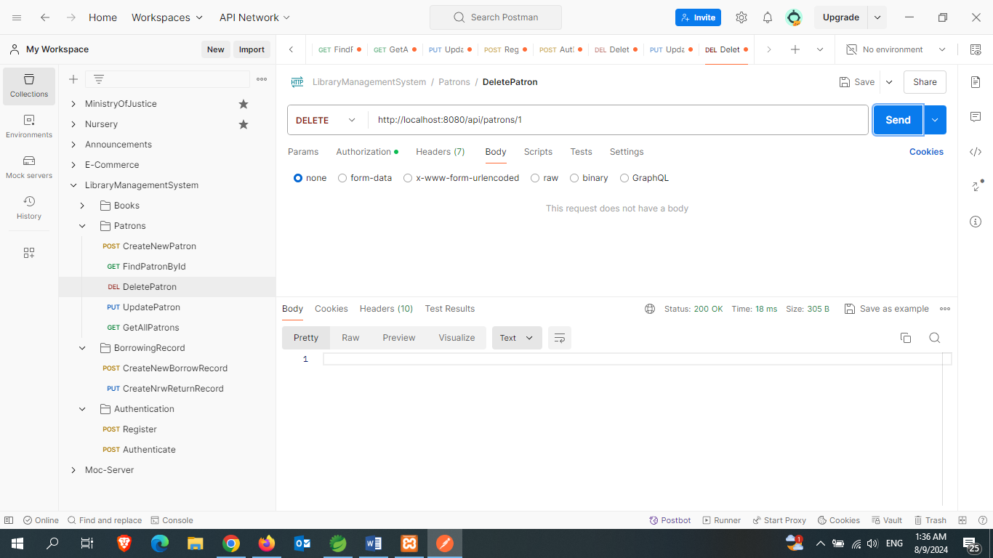

1. **Create New Borrow Record**

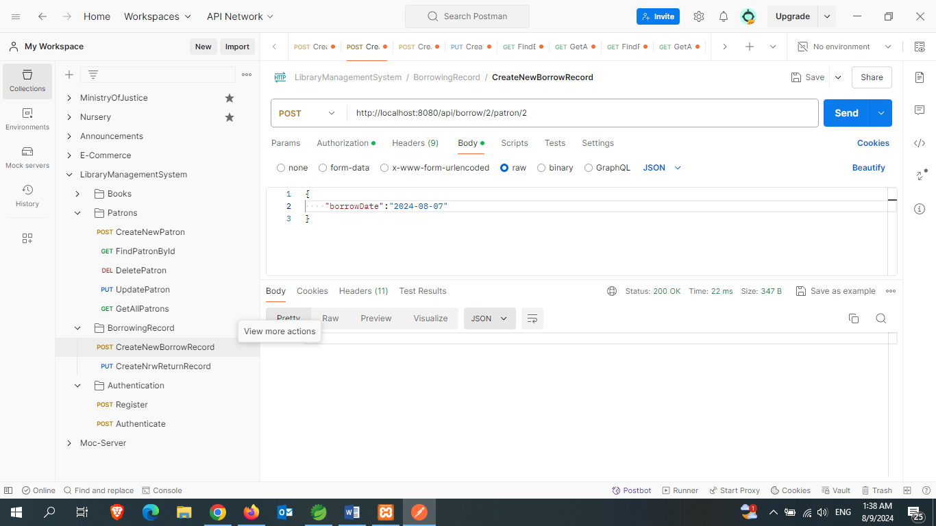

1. **Create New Return Record**

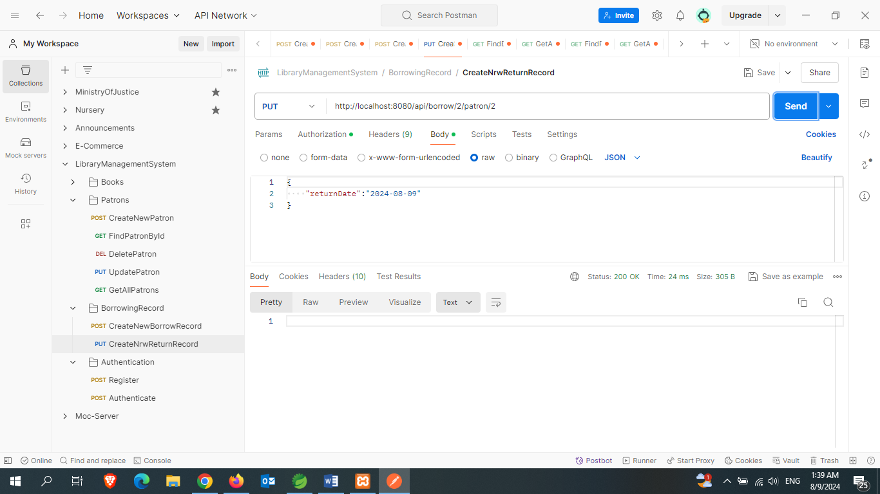

* **Aspect Oriented Programming:**

-Creating a class acts as an aspect using @aspect annotation to log the method data

As its name , service and execution time at join point “**serviceImple**” package.

-using dependency “**spring-boot-starter-aop**” to implement this method

* **Unit testing:**

-Creating unit testing for many test cases for each end point using “**Springboot test”**

and “**Mockito**” with dependency ”**spring-boot-starter-test**”

* **Transactional:**

- Using “**@Transactional**” annotation Spring manages the transaction automatically, ensuring that the method runs within a transaction context. If an exception occurs during the method execution, the transaction is rolled back; otherwise, it's committed.

* **Swagger Documentation:**

-Using “**Swagger**” for the visual documentation for the project by fetching this url

[**http://localhost:8080/swagger-ui/index.html**](http://localhost:8080/swagger-ui/index.html)

-Using dependency “**org.springdoc**” to implement swagger documentation

* **Caching:**

-Using springboot caching with “**@Cacheable**” annotation to improve end point performance with dependency “**spring-boot-starter-cache**”

* **Error Handling And Validations:**

-Using springboot validations like **@NotNull** and **@NotBlank** to validate end points data and handle the project errors with obvious message for the error. this helps to now the reason of error rapidly

-Using dependency “**spring-boot-starter-validation**” and “ **javax.validation**”